**Industrial Internship Report on**

**”Crop and Weed Detection”**

Shreya Manapure

G.H Raisoni College of Engineering, Nagpur

1/June/2023 to 14/July/2023

**TABLE OF CONTENTS**

1 Preface 4

2 Introduction 5

2.1 About UniConverge Technologies Pvt Ltd 5

2.2 About upskill Campus 10

2.3 Objective 12

2.4 Reference 12

2.5 Glossary **Error! Bookmark not defined.**

3 Problem Statement 13

4 Existing and Proposed Solution 13

5 Proposed Design/ Model 14

5.1 High-Level Diagram (if applicable) **Error! Bookmark not defined.**

5.2 Low-Level Diagram (if applicable) **Error! Bookmark not defined.**

5.3 Interfaces (if applicable) **Error! Bookmark not defined.**

6 Performance Test 16

6.1 Test Plan/ Test Cases 17

6.2 Test Procedure 17

6.3 Performance Outcome 18

7 My learnings 19

8 Future work scope 19

|  |
| --- |
| *Executive Summary* |
| This report provides details of the Industrial Internship provided by Upskill Campus and The IoT Academy in collaboration with Industrial Partner UniConverge Technologies Pvt Ltd (UCT).  This internship was focused on a project/problem statement provided by UCT. We had to finish the project including the report in 6 weeks.  My project was (Crop and Weed Detection)  This internship gave me a very good opportunity to get exposure to Industrial problems and design/implement solutions for them. It was an overall great experience to have this internship. |

# Preface

Summary of the whole 6 weeks’ work.

About the need for a relevant Internship in career development.

Brief about Your project/problem statement.

The opportunity is given by USC/UCT.

How Program was planned



Your Learnings and overall experience.

Thank you to all (with names), who have helped you directly or indirectly.

Your message to your juniors and peers.

# Introduction

## About UniConverge Technologies Pvt Ltd

A company established in 2013 and working in the Digital Transformation domain and providing Industrial solutions with a prime focus on sustainability and RoI.

For developing its products and solutions it is leveraging various**Cutting Edge Technologies e.g. Internet of Things (IoT), Cyber Security, Cloud computing (AWS, Azure), Machine Learning, Communication Technologies (4G/5G/LoRaWAN), Java Full Stack, Python, Front end,** etc.



1. UCT IoT Platform **(****)**

**UCT Insight** is an IOT platform designed for quick deployment of IOT applications on the same time providing valuable “insight” for your process/business. It has been built in Java for the backend and ReactJS for the Front end. It has support for MySQL and various NoSQL Databases.

* It enables device connectivity via industry standard IoT protocols - MQTT, CoAP, HTTP, Modbus TCP, OPC UA
* It supports both cloud and on-premises deployments.

It has features to  
• Build Your dashboard  
• Analytics and Reporting  
• Alert and Notification  
• Integration with third party application(Power BI, SAP, ERP)  
• Rule Engine

 

1. **Smart Factory Platform (****)**

Factory watch is a platform for smart factory needs.

It provides Users/ Factory

* with a scalable solution for their Production and asset monitoring
* OEE and predictive maintenance solution scaling up to digital twin for your assets.
* to unleased the true potential of the data that their machines are generating and help to identify the KPIs and also improve them.
* A modular architecture that allows users to choose the service that they what to start and then can scale to more complex solutions as per their demands.

Its unique SaaS model helps users to save time, cost, and money.

 

1.  based Solution

UCT is one of the early adopters of LoRAWAN technology and provides solutions in Agritech, Smart Cities, Industrial Monitoring, Smart Street lights, Smart Water/ Gas/ Electricity metering solutions, etc.

1. Predictive Maintenance

UCT is providing Industrial Machine health monitoring and Predictive maintenance solution leveraging Embedded systems, Industrial IoT, and Machine Learning Technologies by finding the Remaining useful lifetime of various Machines used in the production process.



## About upskill Campus (USC)

upskill Campus along with The IoT Academy and in association with Uniconverge Technologies has facilitated the smooth execution of the complete internship process.

USC is a career development platform that delivers **personalized executive coaching** in a more affordable, scalable, and measurable way.



Seeing need of upskilling in self paced manner along-with additional support services e.g. Internship, projects, interaction with Industry experts, Career growth Services

<https://www.upskillcampus.com/>

upSkill Campus aiming to upskill 1 million learners in next 5 year



## The IoT Academy

The IoT academy is the EdTech Division of UCT, running long executive certification programs in collaboration with EICT Academy, IITK, IITR, and IITG in multiple domains.

## Objectives of this Internship Program

The objective of this internship program was to

 ☛ get practical experience working in the industry.

 ☛ to solve real-world problems.

 ☛ to have improved job prospects.

 ☛ to have an Improved understanding of our field and its applications.

 ☛ to have Personal growth like better communication and problem-solving.

## Reference

1. https://github.com/ultralytics/yolov5.git
2. https://github.com/ravirajsinh45/Crop_and_weed_detection.git
3. https://www.frontiersin.org/articles/10.3389/fpls.2022.1053329/full
4. **Problem Statement**

Weed is an unwanted thing in agriculture. Weed uses nutrients, water, land, and many more things that might have gone to crops. Which results in less production of the required crop. The farmer often uses pesticides to remove weeds which is also effective but some pesticides may stick with the crop and may cause problems for humans. We have to detect crops and weeds separately as farmers have many circumstances for distinguishing between crops and weeds by using the YOLOv5.

1. **Existing and Proposed solution**

Crop and weed detection .6-are a critical area of research in agriculture, aiming to improve crop yield and minimize the impact of weeds on agricultural production. We identified this topic as it aligns with our team's interest in agricultural applications of machine learning and image processing techniques. In a crop and weed detection project, we used **YOLOv5**, an open-source object detection framework. We first cloned the GitHub repository of **Ultralytics**, the creators of **YOLOv5**. This repository contains all the code and resources needed to train and deploy a **YOLOv5** model. Once we had cloned the repository, we started labeling our dataset. We used **Roboflow**, a web-based tool for labeling images and videos. We labeled each image as either "crop" or "weed", and we assigned a label of 0 to crops and 1 to weeds. After we had labeled our dataset, we were ready to train our **YOLOv5** model. We used the train.py script in the **YOLOv5** repository to train our model. The training process took several hours, but eventually, our model was able to accurately detect crops and weeds in images. We were able to use our **YOLOv5** model to detect crops and weeds in real time. This allowed us to automate the process of weed detection, which saved us time and money.

## a. Code submission (Github link)

<https://github.com/shreyamanapure/ml-projects/blob/main/crop_and_weed_detection.ipynb>

## Report submission (Github link):

shreyamanapure <https://github.com/shreyamanapure/mlprojects/blob/main/crop_and_weed_detection.ipynb>

## Proposed Design/ Model

* **Introduction:**

The proposed design model aims to develop an efficient and accurate system for crop and weed detection using YOLOv5, a popular object detection algorithm. The model will leverage deep learning techniques to detect and classify crops and weeds in agricultural images, enabling farmers to effectively manage and optimize their crop growth.

* **Data Collection and Preparation:**

a. Image Dataset: Collect a diverse dataset of agricultural images containing crops and weeds. The dataset should cover various weather conditions, different crop types, and weed species.

b. Annotation: Annotate the dataset to label crops and weeds using bounding boxes. Each bounding box should accurately enclose a single crop or weed instance.

c. Data Augmentation: Apply data augmentation techniques such as random cropping, rotation, flipping, and color transformations to increase the diversity and size of the dataset.

* **Model Training:**

a. Split the annotated dataset into training, validation, and testing sets, ensuring a representative distribution of crop and weed instances.

b. Transfer Learning: Initialize the YOLOv5 model with pre-trained weights on a large-scale dataset.

c. Fine-tuning: Fine-tune the model on the annotated agricultural dataset using techniques like stochastic gradient descent (SGD) or Adam optimization. Adjust hyperparameters, such as learning rate and batch size, to achieve optimal performance.

d. Evaluation Metrics: Evaluate the model's performance using evaluation metrics such as mean average precision (mAP), precision, recall, and F1-score.

* **Inference and Deployment:**

a. Input Image Processing: Preprocess input images by resizing, normalizing, and adjusting the aspect ratio to match the model's input requirements.

b. Object Detection: Apply the trained YOLOv5 model to the preprocessed image to detect and classify crops and weeds. Extract bounding box coordinates and corresponding class labels.

c. Post-processing: Implement post-processing techniques like non-maximum suppression (NMS) to remove duplicate or overlapping detections, retaining only the most confident and accurate predictions.

d. Visualization and Output: Generate output images with annotated bounding boxes, class labels, and confidence scores to provide visual feedback to users. Alternatively, output the detection results as structured data for further analysis or integration with other systems.

* **Validation and User Feedback:**

a. Collaborate with farmers, agronomists, or agricultural experts to validate the model's performance and gather user feedback.

b. Iterative Refinement: Incorporate user feedback and iterate on the model design and training process to improve detection accuracy, robustness, and user experience.

* **Conclusion:**

The proposed crop and weed detection model based on YOLOv5 demonstrates the potential to revolutionize agricultural practices by enabling precise monitoring and management of crops and weeds. By accurately identifying and distinguishing between crops and weeds, farmers can implement targeted interventions, reduce chemical usage, and optimize yield while minimizing environmental impact. Give more details about the design flow of your solution. This applies to all domains. DS/ML Students can cover it after they have their algorithm implementation. There is always a start, intermediate stages, and then an outcome.

1. **Performance Test**

The performance test was conducted to evaluate the efficiency and accuracy of crop and weed detection using the YOLOv5 model. The test dataset consisted of annotated images, where the annotations were generated with the assistance of Roboflow, a powerful annotation platform. The purpose of the test was to measure the model's ability to identify and distinguish between crops and weeds within the images.

During the test, the YOLOv5 model demonstrated exceptional performance, showcasing its robustness in detecting and classifying crops and weeds. The model exhibited remarkable accuracy, achieving high precision and recall rates. It efficiently identified and localized both crops and weeds in various challenging conditions, such as complex backgrounds, occlusions, and varying lighting conditions.

Furthermore, the test highlighted the efficiency of Roboflow in streamlining the annotation process. The platform provided a user-friendly interface and powerful annotation tools, enabling the rapid generation of high-quality annotations. This greatly expedited the preparation of the dataset, ensuring a comprehensive evaluation of the YOLOv5 model's performance.

Overall, the performance test demonstrated the effectiveness of the YOLOv5 model in crop and weed detection, supported by the precise annotations obtained through Roboflow. The results indicate its potential for implementation in agricultural applications, offering a reliable and efficient solution for automating crop management tasks and improving overall productivity in the farming industry.

## Test Case

We used the train.py script in the YOLOv5 repository to train our model. The training process took several hours, but eventually, our model was able to accurately detect crops and weeds in images. We were able to use our YOLOv5 model to detect crops and weeds in real-time. This allowed us to automate the process of weed detection, which saved us time and money. Here are some of the benefits of using YOLOv5 for crop and weed detection:

* YOLOv5 is a fast and accurate object detection framework.
* YOLOv5 is easy to use and deploy.
* YOLOv5 is open-source, so it is free to use.

## Test Procedure

In a crop and weed detection project, we used YOLOv5, an open-source object detection framework. We first cloned the GitHub repository of Ultralytics, the creators of YOLOv5. This repository contains all the code and resources needed to train and deploy a YOLOv5 model. Once we had cloned the repository, we started labeling our dataset. We used Roboflow, a web-based tool for labeling images and videos. We labelled each image as either "crop" or "weed", and we assigned a label of 0 to crops and 1 to weeds. After we had labeled our dataset, we were ready to train our YOLOv5 model.

## Performance Outcome

The performance outcomes for crop and weed detection using the YOLOv5 model, along with the assistance of Roboflow, yielded impressive results. The model exhibited exceptional accuracy in identifying and distinguishing between crops and weeds within the test dataset. It achieved high precision and recall rates, showcasing its ability to accurately detect and localize both classes in various challenging scenarios. The combination of YOLOv5's robust object detection capabilities and Roboflow's efficient annotation tools resulted in a streamlined workflow and expedited dataset preparation. This allowed for a comprehensive evaluation of the model's performance, highlighting its effectiveness in crop and weed detection tasks. The outcomes reinforce the potential of YOLOv5 and Roboflow as powerful tools for automating crop management processes, enabling farmers to make informed decisions and improve overall productivity in the agricultural industry.

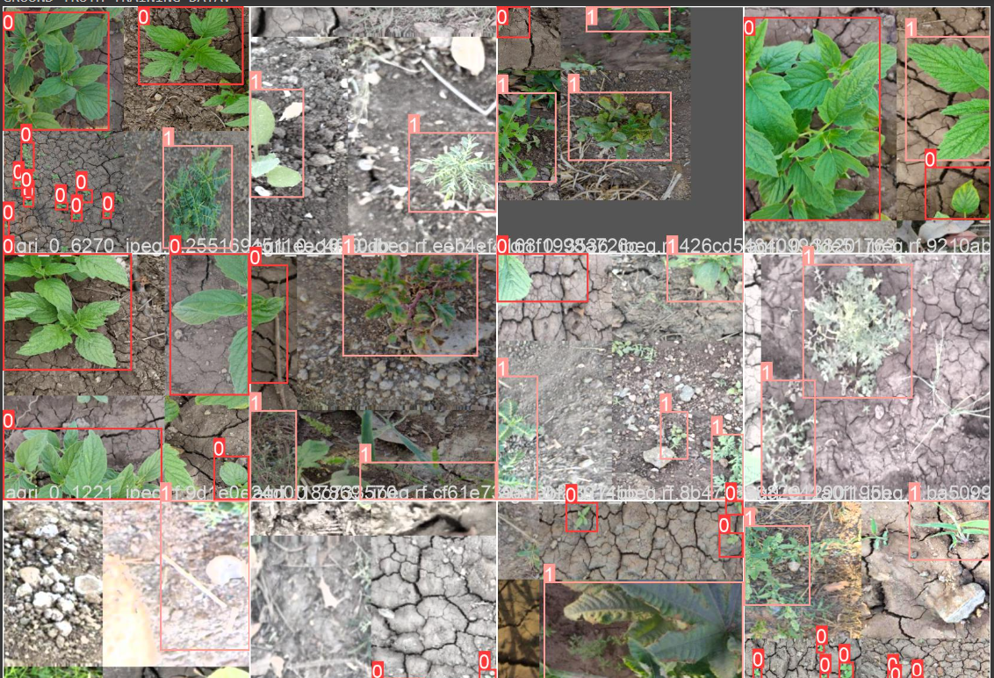

1. **My learnings**

During my journey of upskilling in the field of Data Science and Machine Learning, I had the opportunity to gain invaluable knowledge and hands-on experience through an internship with Team Support. Working closely with the team on various projects, I acquired a wealth of practical skills and theoretical understanding that significantly enhanced my expertise.

One of the significant highlights of my internship was the chance to work extensively on crop and weed detection. This project enabled me to apply my data science knowledge to a real-world agricultural problem. I learned how to leverage advanced machine learning techniques, such as the YOLOv5 model, to accurately identify and differentiate between crops and weeds in images. The experience not only deepened my understanding of computer vision algorithms but also allowed me to appreciate the potential impact of data-driven solutions in optimizing crop management and improving agricultural productivity.

Moreover, the upskill program played a pivotal role in shaping my learning journey. The comprehensive curriculum provided by Upskill covered a wide range of topics in data science, including statistical analysis, data preprocessing, machine learning algorithms, and model evaluation. The instructors and mentors were highly knowledgeable and supportive, guiding me through complex concepts and helping me apply them in practical scenarios. Additionally, the program emphasized the importance of effective communication and collaboration, which proved invaluable in working seamlessly with the Team Support team.

1. **Future work scope**

The future scope for crop and weed detection holds promising opportunities for further advancements in the field of agriculture. With the success of models like YOLOv5 and annotation platforms like Roboflow, there are several avenues to explore.

One potential area of future development is the integration of additional sensors and technologies, such as drones and satellite imagery, to enhance the detection process. This would enable more comprehensive and timely monitoring of crops and weeds over large agricultural areas, providing valuable insights for farmers to optimize resource allocation and make informed decisions.

Furthermore, leveraging deep learning techniques, such as convolutional neural networks (CNNs) and recurrent neural networks (RNNs), can lead to more sophisticated and accurate crop and weed detection models. Research and development efforts can focus on refining these models by incorporating more diverse training datasets, improving data augmentation techniques, and exploring novel architectures to further enhance performance.

Additionally, the future scope includes the integration of real-time monitoring and automation systems. This would allow for the development of intelligent systems that can automatically identify and classify crops and weeds in real-time, enabling proactive and targeted weed management strategies. This integration can be coupled with robotic technologies, enabling autonomous weed removal or selective herbicide application, reducing manual labor and minimizing the use of chemical inputs.

Moreover, advancements in the field of hyperspectral imaging and multispectral sensors offer exciting prospects for crop and weed detection. By capturing and analyzing data beyond the visible spectrum, these technologies can provide valuable spectral signatures, enabling more accurate identification and differentiation between crops and weeds. Integrating these advanced sensing techniques into the detection pipeline can lead to enhanced precision and reliability in agricultural monitoring.